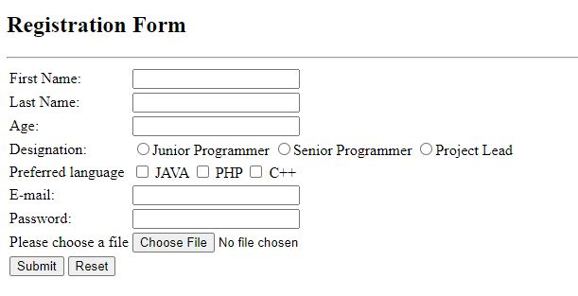

Create a program that will insert user data in to database using above FORM and after insertion display the data from the database.